DA 505 HOMEWORK 2 (PART 1) - FALL 2021

Oracle orcl Database HR Schema

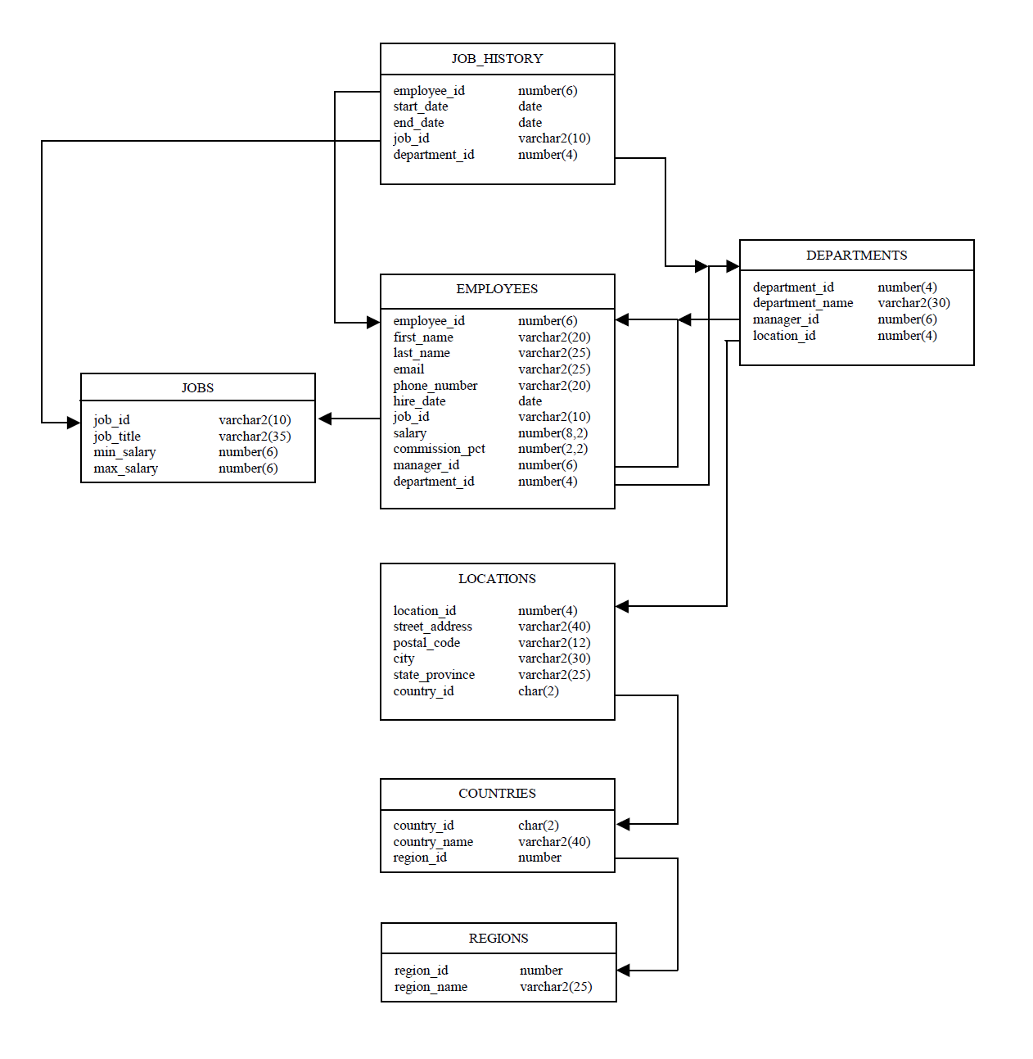

- Create a query that displays the EMPLOYEES’ last names, salaries and commission amounts. If an employee does not earn commission, put “No Commission.”

select last_name, salary, nvl(to_char(commission_pct*salary),'No comission') Commission
from hr.employees;

- Create a query that displays the EMPLOYEES’ last_names and their annual salaries. To calculate the annual salary, use the formula (salary*12)+(salary*12*commission_pct). Order the result by annual salary in descending order.
Hint: Use NVL function to avoid null results

select last_name, salary*12*(1+ nvl(commission_pct,0)) AnnualIncome
from hr.employees
order by AnnualIncome desc;

- Display the employee last name and department name for all EMPLOYEES who have an r (lowercase) in their last names. Show only the EMPLOYEES whose job_id is SA_MAN. Order the result by salary.

SELECT
hr.employees.last_name,
hr.departments.department_name
FROM
hr.employees
INNER JOIN hr.departments ON hr.employees. department_id = hr.departments.department_id
WHERE
hr.employees.job_id = 'SA_MAN'
AND hr.employees.last_name LIKE '%r%'
ORDER BY
hr.employees.salary;

- Write a query to display the last name for all EMPLOYEES who work in Toronto.

SELECT
hr.employees.last_name
FROM
hr.employees
INNER JOIN hr.departments ON hr.employees.department_id = hr.departments.department_id
INNER JOIN hr.locations ON hr.departments.location_id = hr.locations.location_id
WHERE
hr.locations.city = 'Toronto';

- Display the names, hire dates and salaries of all EMPLOYEES who were hired before their managers, along with their manager’s names and hire dates.
Hint: Use a self join

Select e.first_name, e.hire_date, e.salary, m.first_name, m.hire_date
from hr.employees e
inner join hr.employees m on (e.manager_id=m.employee_id)
where
e.hire_date < m.hire_date

- Write a query to display the employee last name, department name and city of all EMPLOYEES who earn more than $5000.

select last_name, department_name, city
from hr.employees e
inner join hr.departments d on (e.department_id=d.department_id)
inner join hr.locations l on (l.location_id=d.location_id)
where
e.salary>5000;

- Write a query to display the number of people with the same job.

select job_id,count(*)
from hr.employees
group by
job_id;

- Determine the number of managers without listing them. Label the column Number of Managers.
Hint: Use the distinct clause and MANAGER_ID column to determine the number of managers
select count(distinct manager_id) from hr.employees
where manager_id is not null; -- bu olmasa da olur

- Write a query that displays the difference between the highest and lowest salaries.

select max(salary), min(salary), max(salary)-min(salary) as RangeInSalary from hr.employees;

- Display the manager number and the SALARY of the lowest paid employee for that manager. Exclude anyone whose manager is not known. Exclude any groups where the minimum SALARY is $5,000 or less. Sort the output in descending order of SALARY.

select manager_id, min(salary)
from hr.employees
where
manager_id is not null
group by
manager_id
having
min(salary)>5000
order by 2 desc;

- Create a query that displays the employee last name, job title, department name and starting date for all jobs from 2001 to 2005.
Hint: Use to_char(colum_name,’YYYY’)

Select last_name, job_title, department_name, h.start_date
from hr.employees e
inner join hr.job_history h on (e.employee_id=h.employee_id)
inner join hr.jobs j on (h.job_id=j.job_id)
inner join hr.departments d on (h.department_id=d.department_id)
where to_char(h.start_date,'YYYY') between 2001 and 2005;

- The HR department needs a report for display the ID for those employees who did two or more jobs in the past.

select employee_id from hr.job_history
group by
employee_id
having
count(*)>1;

- Write a query in SQL to display the first and last name, and department number for those employees who holds a letter s as a 3rd character in their first name.

select first_name, last_name,department_id
from hr.employees e
where
first_name like '__s%';

- Write a query to display the last name for all EMPLOYEES who work in Seattle or London.

select last_name, city
from hr.employees e
inner join hr.departments d on (e.department_id=d.department_id)
inner join hr.locations l on (d.location_id=l.location_id)
where
city in ('London','Seattle');

- List the last_name and salary of employees who earn between $5000 and $12000, and are in department 20 or 50. Label the columns Employee and Monthly Salary.

select last_name Employee, salary "Monthly Salary"
from hr.employees e
where
salary between 5000 and 12000
and (department_id =20 or department_id=50);

- Write a query to display the employee last name, department name, city and country of all EMPLOYEES who earn more than $7500.

select last_name, department_name, city, country_name
from hr.employees e
inner join hr.departments d on (e.department_id=d.department_id)
inner join hr.locations l on (d.location_id=l.location_id)
inner join hr.countries c on (l.country_id=c.country_id)
where
salary>7500;

- Write a query to display the department number, department name, number of people with the same department and department avarage salary. Sort the output in descending order of avarage salary.

select d.department_id, department_name, count(*), round(avg(salary)) OrtMaas
from hr.employees e
inner join hr.departments d on (e.department_id=d.department_id)
group by
d.department_id,department_name
order by OrtMaas desc;

- List the employees who did not do any job in the past.

select e.employee_id, first_name, last_name
from hr.employees e
where
not exists (
select 1
from hr.job_history h
where
e.employee_id=h.employee_id
);

- Wirte a sql to find the city of employee whose employee ID is 107.

select city
from hr.employees e
inner join hr.departments d on (e.department_id=d.department_id)
inner join hr.locations l on (d.location_id=l.location_id)
where
e.employee_id=107;

- Display first name, last_name, hire date and date of first salary of the employees.
Hint: Use a date function

with fs as (select employee_id, min(start_date) mindate
from hr.job_history
group by employee_id)
select first_name, last_name, hire_date,fs.mindate,
last_day(
case when
fs.mindate is null then hire_date
else fs.mindate
end) FirstSalaryDate
from hr.employees e
left join fs
on (e.employee_id=fs.employee_id)

NOT:maaşın aysonu alındığı varsayılmıştır.

MySQL (sakila) / PostgreSQL (dvdrental) Database

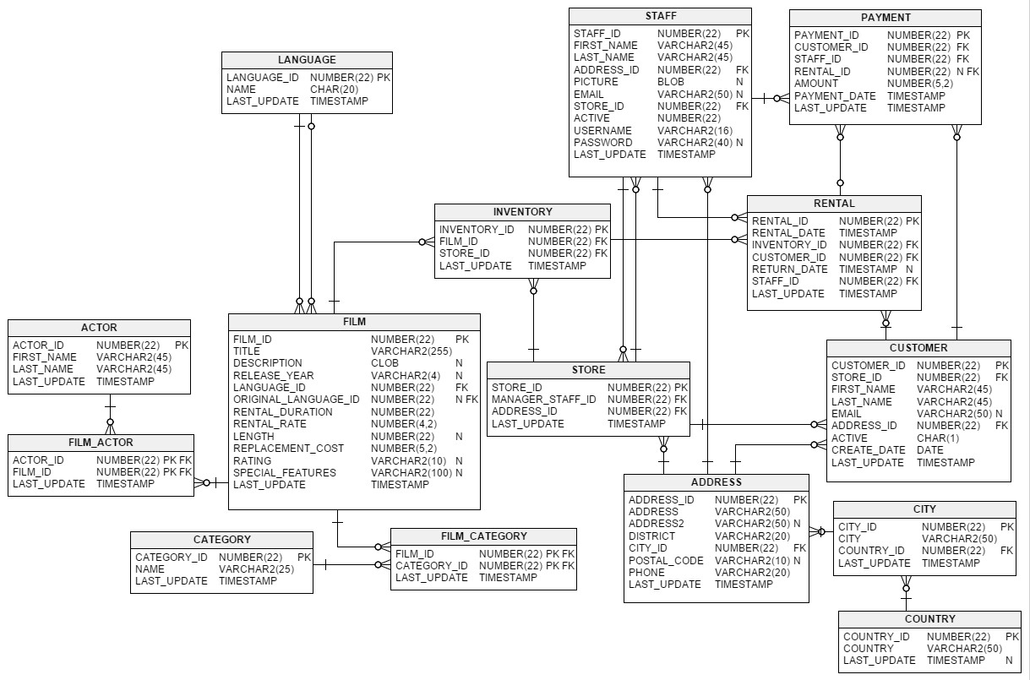

- Write a query to display actor first name, actor last name, film title and film category which films involve a ‘Cat’ or ‘Dog’.

select a.first_name, a.last_name, f.title, c.name
from actor a
inner join film_actor fa on (fa.actor_id=a.actor_id)
inner join film f on (f.film_id=fa.film_id)
inner join film_category fc on (fc.film_id=f.film_id)
inner join category c on (c.category_id=fc.category_id)
where
f.description like '%cat%'
or
f.description like '%dog%';

- Find the actor who has appeared in the most films?

select a.actor_id,a.first_name,a.last_name, count(*)
from actor a
inner join film_actor fa on (fa.actor_id=a.actor_id)
group by
a.actor_id,a.first_name,a.last_name
order by 4 desc
limit 1

Burda actor_id çıkartıldığında susan davis oluyor, bunun sebebi iki susan davis olamsı, biri 101, diğeri 110 id’li

- Create a query to find countries with more than one city?

select c.country_id,c.country,count(*) from
country c
inner join city t on (c.country_id=t.country_id)
group by c.country_id, c.country
having
count(*)>1;

- List the number of actors first name and last name starts with same character?

select a.first_name, a.last_name
from actor a
where
substr(a.first_name,1,1)=substr(a.last_name,1,1)

- Write a query to find how many movies are there in each language?

select l.name, count(f.film_id)
from language l
left join film f on (f.language_id=l.language_id)
group by
l.name;

(Bu soruda count(*) yapınca İngilizce dışındaki dillerede neden 0 değil de 1 getirdiğini anlayamadım, bunu bi ara açıklayabilirseniz sevinirim)

- Find the top 5 customer based on number of rentals?

select customer_id, count(*)
from rental
group by
customer_id
order by 2 desc
limit 1

- Create a query to find the top 10 most common actor name?

select a.first_name, count(*)
from actor a
group by
a.first_name
order by 2 desc
limit 10

- Display the staff id, first name and last name who made more sales in 2007 (use 2006 for MySQL) April based on number of sales?
Hint : Use a date function (For PostgreSQL date_part, for MySQL datediff)

with maxsale as (
select staff_id,count(*) adet from payment
where
extract(year from payment_date)=2006
and extract(month from payment_date)=2
group by
staff_id
order by 2 desc
limit 1
)
select s.staff_id, s.first_name, s.last_name, m.adet
from staff s
inner join maxsale m on (m.staff_id=s.staff_id);

NOT: 2006 nisan değil şubat alınmıştır.

- Write a query to list how many customers returned the film only 1 days later then the rented day?

select count(distinct customer_id) from rental
where datediff(return_date, rental_date)=1

- Write a query to list the top 5 actor/actress first name and last name according to their number of movies?

select a.actor_id,a.first_name,a.last_name, count(*)
from actor a
inner join film_actor fa on (fa.actor_id=a.actor_id)
group by
a.actor_id,a.first_name,a.last_name
order by 4 desc
limit 5

(22.sorunun aynısı gibi, sadece limit 1 yerine limit 5)

- Write a query to list rating and average rental rate of films whose rating R, G, PG or PG-13. List only average rating less than 3

select rating, avg(rental_rate)
from film
where
rating in ('R','G','PG','PG-13')
group by
rating
having
avg(rental_rate)<3

- Write a query to list actors and movies where the movie length was less than 50 minutes

select a.first_name, a.last_name, f.title
from actor a
inner join film_actor fa on (fa.actor_id=a.actor_id)
inner join film f on (f.film_id=fa.film_id)
where
f.length<50

- Find the best customer (id, full name first name with last name) based on total payment?

select c.customer_id,c.first_name, c.last_name, sum(p.amount)
from customer c
inner join payment p on (p.customer_id=c.customer_id)
group by
c.customer_id,c.first_name, c.last_name
order by 4 desc
limit 1

- List Top 10 film category name?

select c.name, count(*) from
film f
inner join film_category fc on (f.film_id=fc.film_id)
inner join category c on (fc.category_id=c.category_id)
group by
c.name
order by 2 desc
limit 10

- Find the last names of actors, as well as how many actors have same last name?

select last_name,count(*)
from actor
group by
last_name

- Display the most frequently rented movies in descending order.

select f.title, count(*) from
film f
inner join inventory i on (f.film_id=i.film_id)
inner join rental r on (r.inventory_id=i.inventory_id)
group by f.title
order by 2 desc

- Use subqueries to display all actors (first name, last name) who appear in the film Ridgemont Submarine.

select first_name,last_name
from actor
where actor_id in (
Select actor_id from
film_actor fa
inner join film f on (f.film_id=fa.film_id)
where
f.title='Ridgemont Submarine'
)

- Which movie has the longest rental duration in ‘Family’ category?

Kendimiz hesaplayarak

select f.film_id,f.title, datediff(r.return_date, r.rental_date) from
film f
inner join film_category fc on (f.film_id=fc.film_id)
inner join category c on (c.category_id=fc.category_id)
inner join inventory i on (f.film_id=i.film_id)
inner join rental r on (i.inventory_id=r.inventory_id)
where
c.name='Family'
order by 3 desc
limit 10;

Hazır kolonu kullanarak

select f.film_id,f.title, f.rental_duration from
film f
inner join film_category fc on (f.film_id=fc.film_id)
inner join category c on (c.category_id=fc.category_id)
where
c.name='Family'
order by 3 desc
limit 14;

- How many Family category movies have rental_rate lower than 2?

select count(*) from
film f
inner join film_category fc on (f.film_id=fc.film_id)
inner join category c on (fc.category_id=c.category_id)
where
c.name='Family'
and f.rental_rate<2

- Write a query that displays actor name, film title, length of movie, and "length category" that classifies movies based on their length (1 hour or less, Between 1-2 hours, Between 2-3 hours, More than 3 hours)

select concat(a.first_name, ' ', a.last_name) actor, f.title, f.length,
case
when f.length<=1*60 then '1 hour or less'
when f.length>1*60 and f.length<=2*60 then 'Between 1-2 hours'
when f.length>2*60 and f.length<=3*60 then 'Between 2-3 hours'
else 'More than 3 hours'
end "length category"
from actor a
inner join film_actor fa on (fa.actor_id=a.actor_id)
inner join film f on (f.film_id=fa.film_id)

